TOWN OF PAONIA
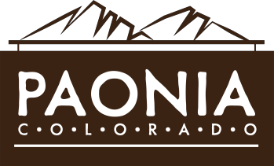
BOARD OF TRUSTEES MEETING
MAYOR REPORT

AGENDA ITEM: | Trustee approval of a statement of fact clarifying approved budgets, purchases and purchasing policy to be distributed publicly.
SUBMITTED BY: | Mayor Smith
DATE: | March 30, 2026
BACKGROUND: | The Town became aware of the attached anonymous flyer (Att. 1.) on March 25th and subsequently learned that this flyer was being distributed throughout Town.  The kind of misinformation and blatant falsehoods included in the flyer denigrating our Town Administrator and us as governing body deserves a unified public response. One of the most dangerous consequences of these kind of untrue accusations being made against our Town is that it can place us in jeopardy with our current granting and lending agencies. If this unfounded negativity is left unanswered, then perception becomes reality and a lasting impression may be erroneously created that we are operating outside of the public interest, making us a lending risk in the present and into the future.  Therefore, please see the attached draft Statement of Fact for your consideration.  If approved, I’m suggesting that we direct staff to submit the letter to the Merchant Herald, High Country Shopper and Delta County Independent as a half-page display ad. By doing so, we can directly control when and where it’s published. The price lists from all three publications are also attached.  In addition, upon seeing the libelous flyer, Trustee Hunter recognized the need for an immediate response to set the record straight and created the second attached flyer on March 26th and posted it throughout Town. This was done on her own accord, after consultation with the Administrator and Town Attorney and did not involve me or any other Trustee. Her flyer is also attached.
BUDGET: | Cost of display ads
RECOMMENDATION: | Make a motion to approve the public statement with any agreed upon changes and publish through display ads.
ATTACHMENTS: | - Anonymous “10 Things Paonia should know about its Town Administrator” flyer.  - Draft Statement of Fact to the public from the Mayor and Trustees  - Merchant Herald display ad price list  - High Country Shopper display ad price list  - Delta County Independent display ad price list  - Flyer refuting the statements made in the original anonymous flyer

